Project Documentation
Team ID: SWTID-2026-3708 | Team Size: 4 | Submitted by: A Yashmin (Team Leader)

1. Introduction
- Project Title: Streamlining IT Procurement: Automating Standard Laptop Orders with Flow Designer
- Team Members: Roles are based on the sprint plan (Project Planning document).
Name | Role | Responsibility
A Yashmin | Team Leader | Flow creation and activation, end-to-end verification, documentation
Rishwana Parveen S | Team Member | Service Catalog trigger, flow assignment, task checks
Deepika Sri M | Team Member | Create Catalog Task action, laptop ordering
Pooja S | Team Member | Field values (description, Hardware group, Approval), request approval

2. Project Overview
- Purpose: To automate the handling of standard laptop requests in ServiceNow. Once a Standard Laptop request is approved, a catalog task is created automatically and assigned to the Hardware team for configuration. This reduces delays, manual effort and missed configuration steps.
- Features:
- Flow “Standard Laptop task” built in Flow Designer (Application: Global, Run As: System User).
- Service Catalog trigger that starts the flow when a catalog request is placed.
- Create Catalog Task action that sets the short description, description, Hardware assignment group and Approval value.
- Flow attached to the Standard Laptop catalog item through the Process Engine tab.
- Catalog task visible under the Requested Item, ready for the Hardware team.

3. Architecture
- Frontend: The ServiceNow Service Catalog UI. Users open Service Catalog > Hardware > Standard Laptop and click Order Now. The Order Status page, Request (REQ), Requested Item (RITM) and Catalog Task (SCTASK) forms are the screens users and approvers work with.
- Backend: Flow Designer logic running on the ServiceNow platform. Trigger: Service Catalog. Action: Create Catalog Task for the Requested Item. The flow is linked to the catalog item under Process Engine, so it runs for every Standard Laptop order.
- Database: ServiceNow tables, with no separate database to set up.
Table | Use in this project
sc_request | The request created when the laptop is ordered (REQ0010001)
sc_req_item | The requested item for the Standard Laptop (RITM0010001)
sc_task | The catalog task created by the flow (SCTASK0010001), assigned to Hardware
sysapproval_approver | The approval record the approver accepts before the task is created

Data flow: Order Now > Request and Requested Item created > Approver approves > Flow runs > Catalog task created for the Hardware group.

4. Setup Instructions
- Prerequisites:
- A ServiceNow instance (for example a Personal Developer Instance) and a user with admin access.
- Flow Designer and Service Catalog available on the instance.
- The Standard Laptop catalog item (category: Hardware) and a group named Hardware.
- Installation: There is nothing to clone or install. Set up the automation on the instance as follows.
- Open All > Flow Designer (under Process Automation) and click New > Flow.
- Name it “Standard Laptop task”, set Application to Global and Run As to System User, then click Submit.
- Add a trigger: search for “Service Catalog”, select it and click Done.
- Add the action Create Catalog Task. Map the Requested Item from the trigger, set Short description and Description to “Laptop needs to Configured”, Assignment group to Hardware and Approval to Approved, then click Done.
- Save and Activate the flow.
- Open All > Maintain Items, select Standard Laptop, go to the Process Engine tab, remove other automations, add the flow and update the record.

5. Folder Structure
ServiceNow does not use project folders. The equivalent navigation paths are:
- Client (user side): Service Catalog > Hardware > Standard Laptop (order page); Requests > REQ > Requested Items > Catalog Tasks (records created by the order).
- Server (admin side): Flow Designer > Flows > Standard Laptop task (logic); Maintain Items > Standard Laptop > Process Engine (where the flow is attached).

6. Running the Application
There are no npm commands. The solution runs inside the instance.
- Frontend: Open Service Catalog > Hardware > Standard Laptop and click Order Now.
- Backend: Make sure the flow shows Active. It starts on its own after the order is approved; no command is needed.

7. API Documentation
The flow does not expose its own API. The records it creates can be read with ServiceNow’s standard Table API (shown for reference; not used in the project).
Method | Endpoint | Purpose
GET | /api/now/table/sc_request | List catalog requests (REQ)
GET | /api/now/table/sc_req_item | List requested items (RITM)
GET | /api/now/table/sc_task?sysparm_query=request_item=<RITM sys_id> | Get the catalog task for a requested item

Example of the fields returned for the catalog task created in testing (trimmed):
{ "number": "SCTASK0010001", "short_description": "Laptop needs to Configured", "assignment_group": "Hardware", "approval": "approved", "request_item": "RITM0010001" }

8. Authentication
- Users sign in to the ServiceNow instance with their own credentials; access is session-based and controlled by roles.
- Authorization: the approver must approve the request (Approvers section) before the flow creates the task. In the test run the approver was Eric Schroeder.
- The flow itself runs as System User, so it can create the catalog task without depending on the ordering user’s permissions.

9. User Interface
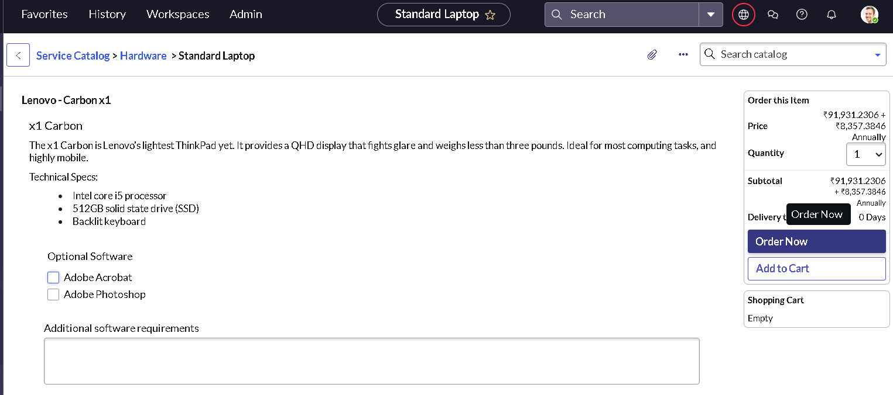
Standard Laptop order page in the Service Catalog
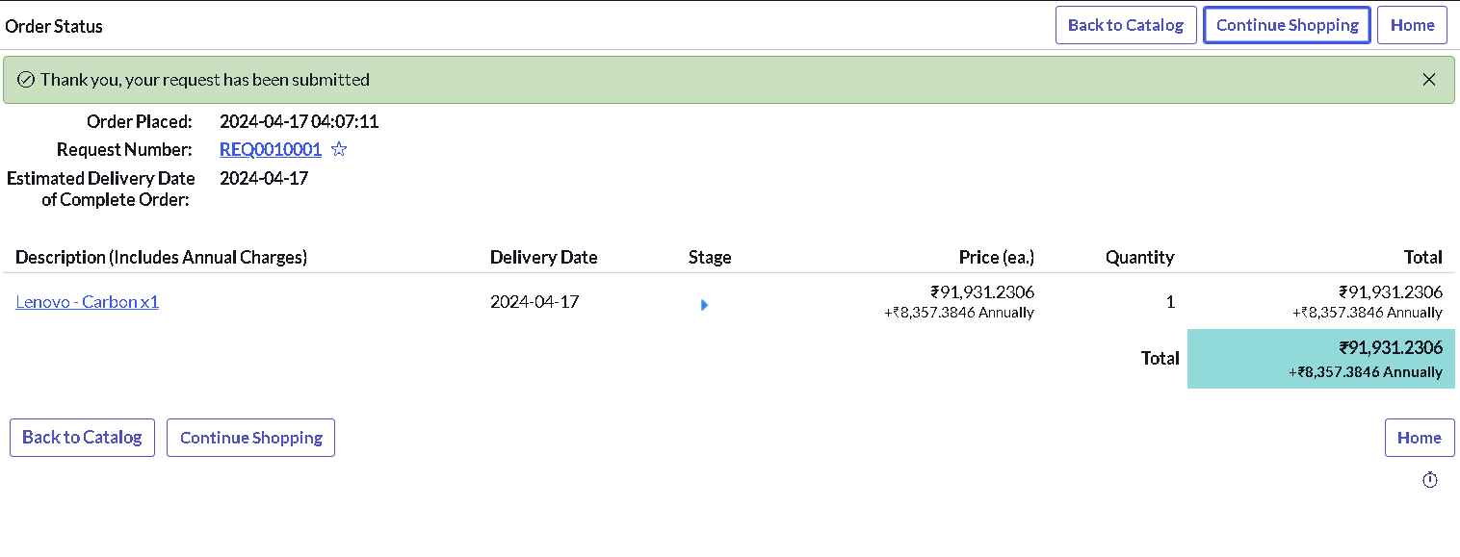
Order Status page showing request REQ0010001
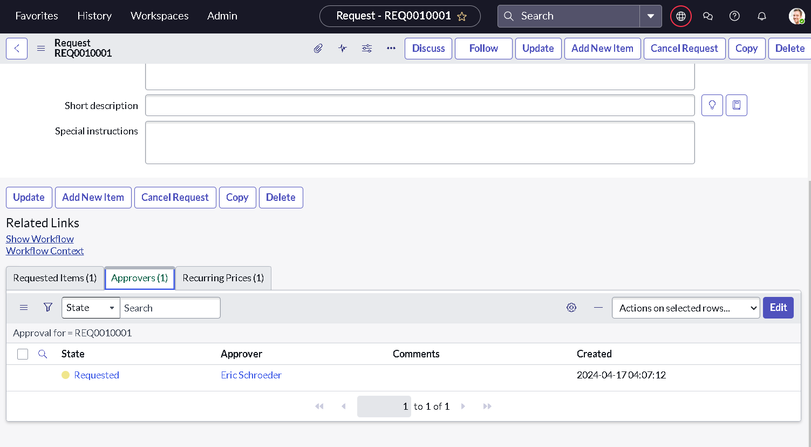
Approvers tab on the request, ready to approve

10. Testing
Testing was manual and end-to-end: order the Standard Laptop, approve the request, open the Requested Item and check the catalog task. Results:
ID | Scenario | Result
FT-01 | Flow creation and properties | Pass
FT-02 | Trigger configuration | Pass
FT-03 | Create Catalog Task action | Pass
FT-04 | Flow activation and catalog item assignment | Pass
PT-01 | Task creation after ordering and approval | Pass (time not measured)
PT-02 | Multiple simultaneous orders | Not tested
PT-03 | Quantity above 1 / optional software | Not tested

11. Screenshots or Demo
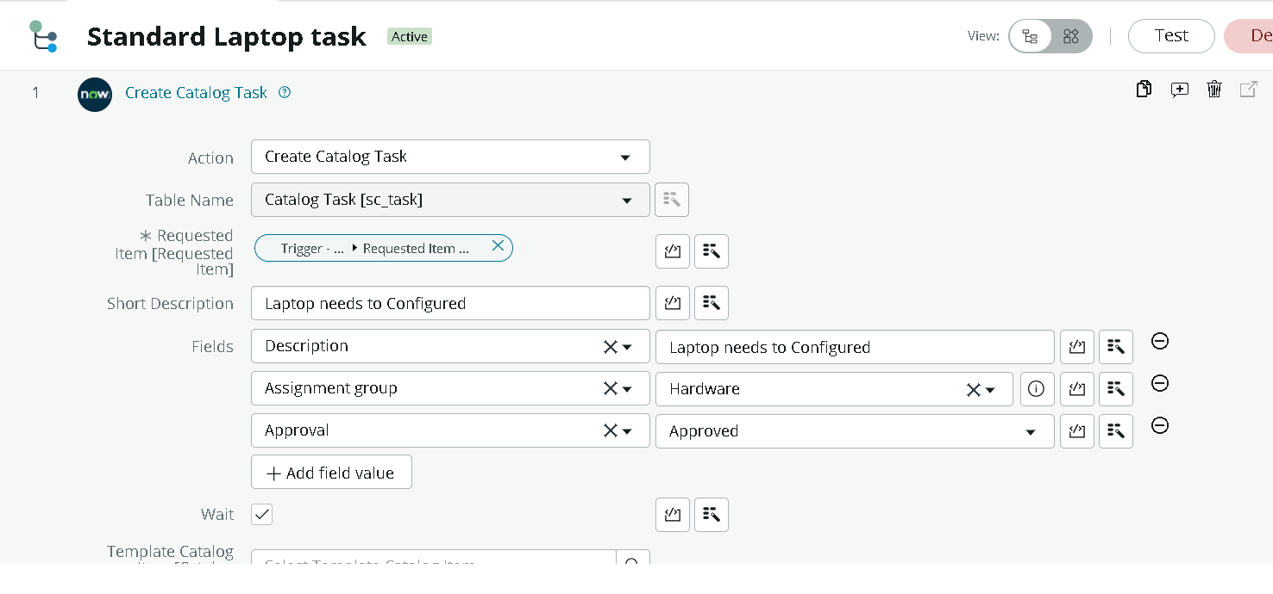
Create Catalog Task action configuration in the flow
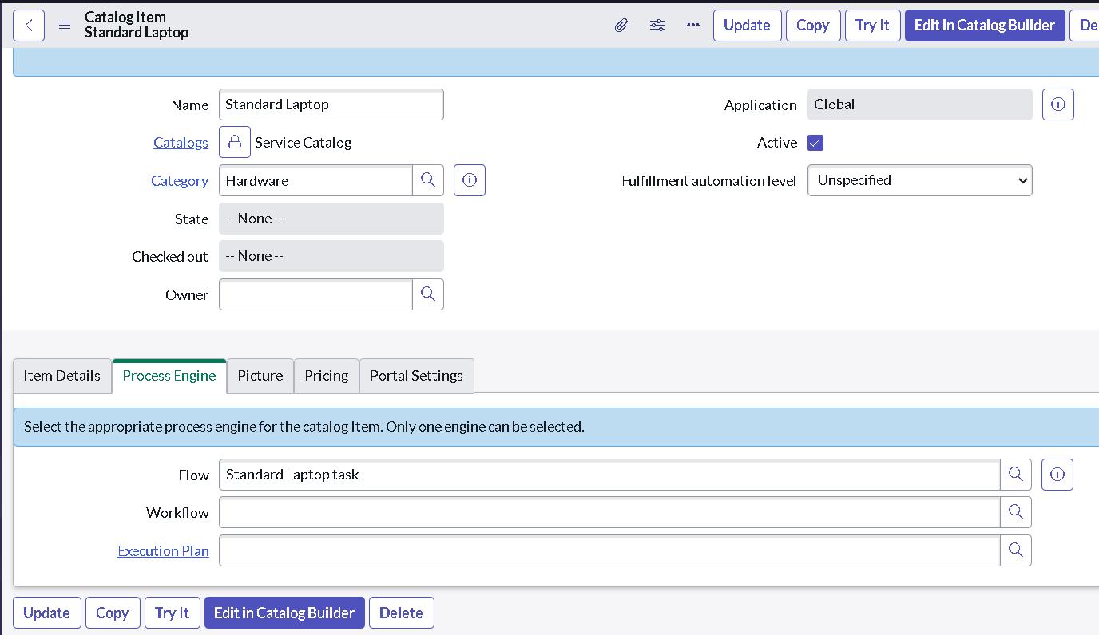
Flow attached to the Standard Laptop item (Process Engine)
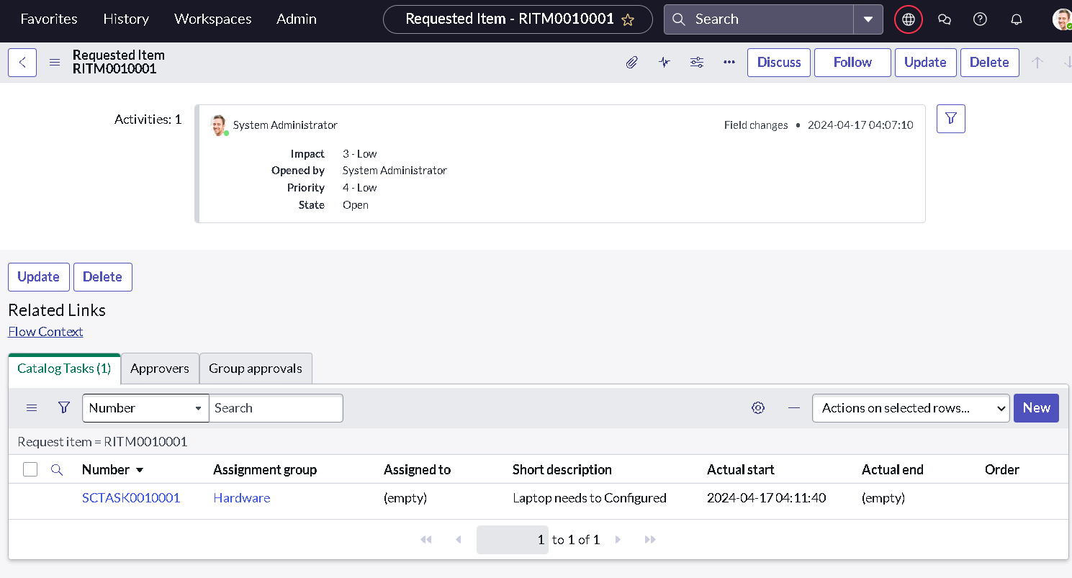
Requested Item showing the catalog task assigned to Hardware
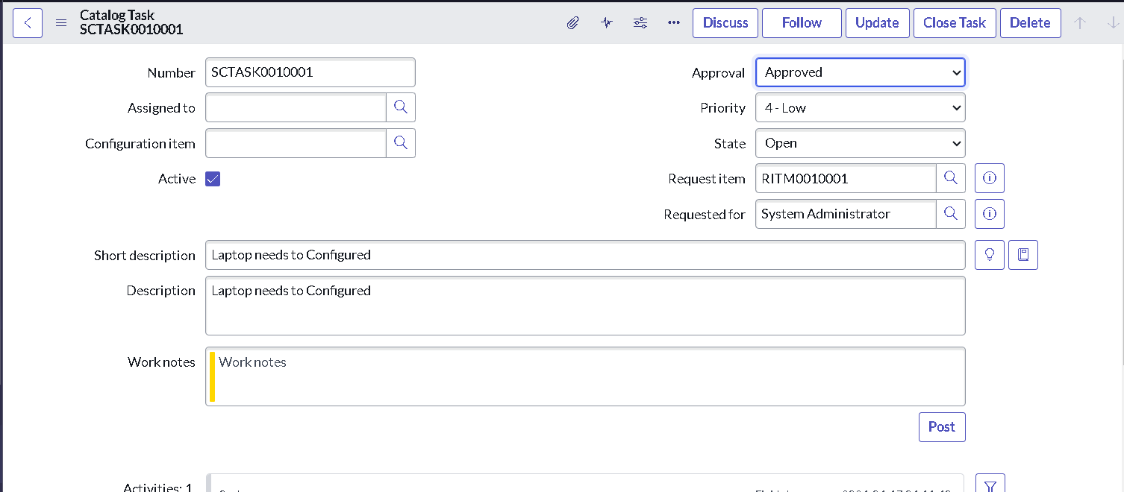
Catalog task SCTASK0010001 with short description and approval

12. Known Issues
- The short description reads “Laptop needs to Configured”; the wording should be “Laptop needs to be configured”.
- The flow sets the task’s Approval field to Approved directly, so that field does not reflect a real approval on the task itself.
- The Service Catalog trigger has no condition, so the flow would run for any catalog item it is attached to.
- Simultaneous orders and orders with a quantity above 1 or optional software have not been tested.

13. Future Enhancements
- Add an email or notification to the Hardware team when a task is created.
- Assign the task to a specific technician, with an SLA and due date.
- Create separate tasks for optional software (Adobe Acrobat, Photoshop).
- Update the request status automatically when the task is closed.
- Extend the same flow to other standard hardware, such as monitors.

